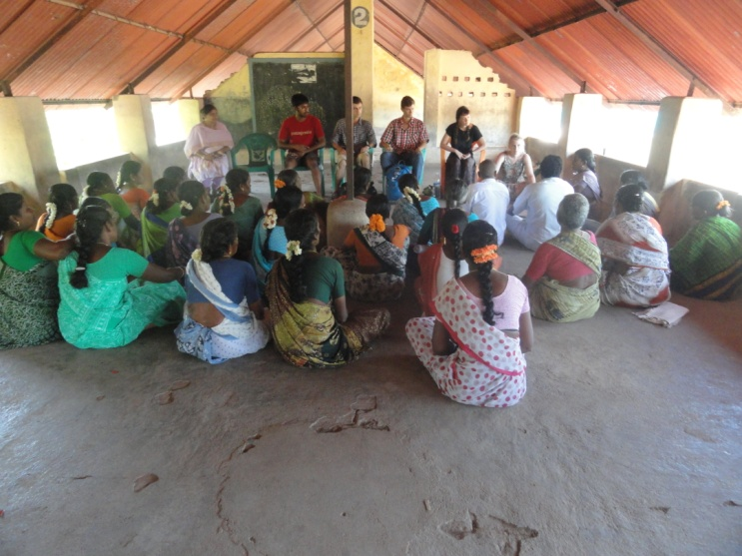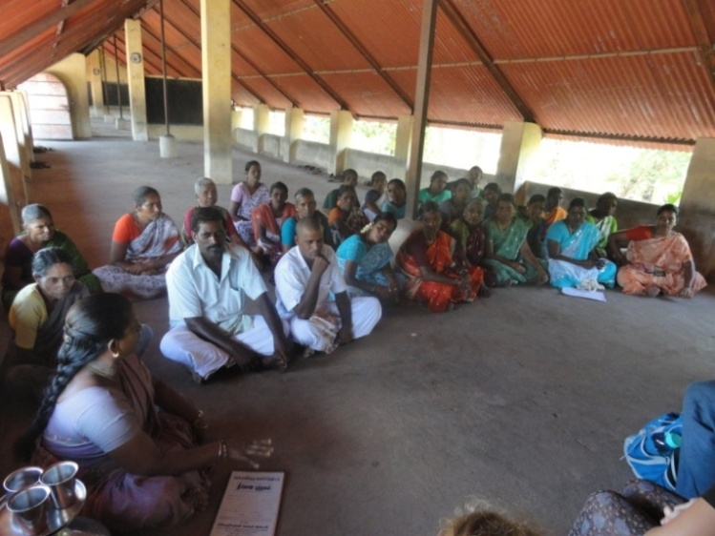
Experience sharing meeting at Endiyur Village Mrs. Tamilselvi, Endiyur Village explaining the methods
followed for toilet construction under PWX

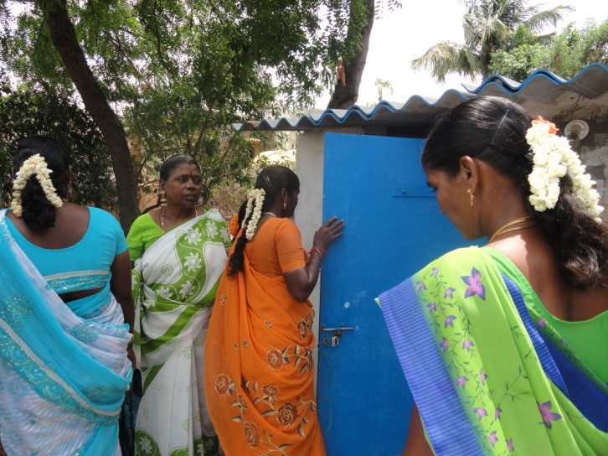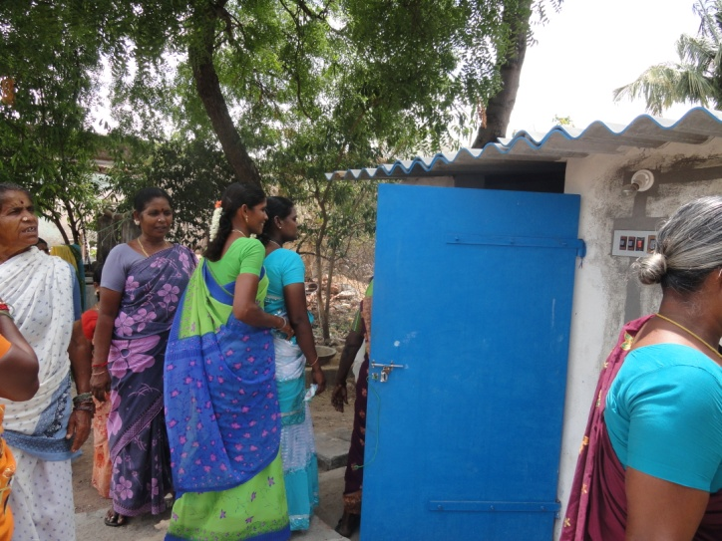
Participants looking the constructed toilet with bathroom

