PHOTOGRAPHIC REPORT: BENEFICIARIES AND HOUSING TYPE – Before Toilet Construction

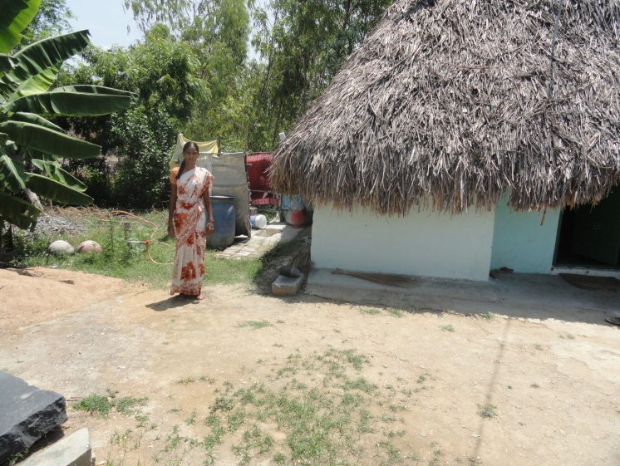 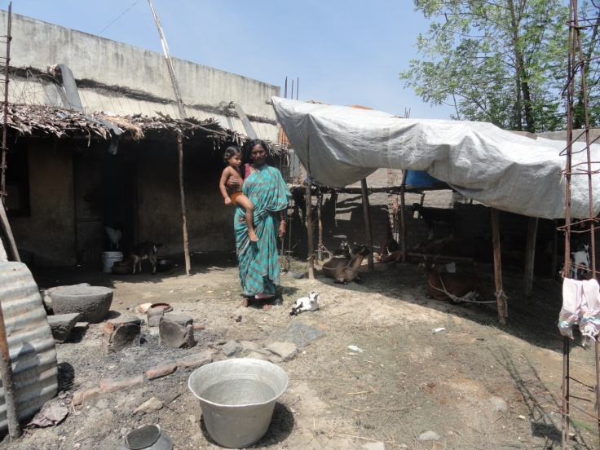

Beneficiary: Mrs.Molavi - House Type: concrete

Beneficiary: Mrs.Devi - House Type: thatched roof

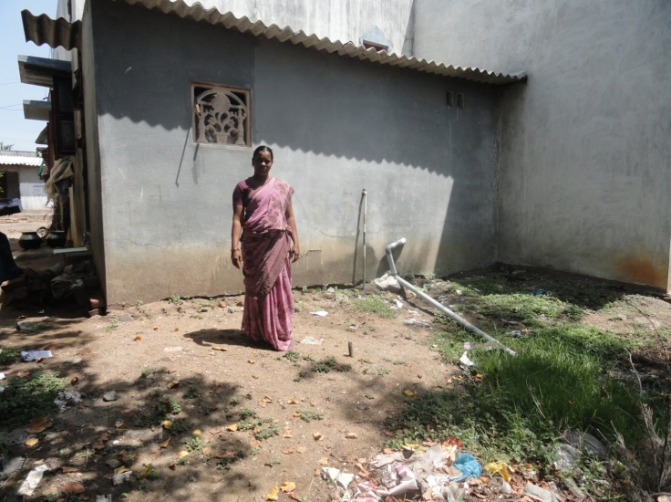 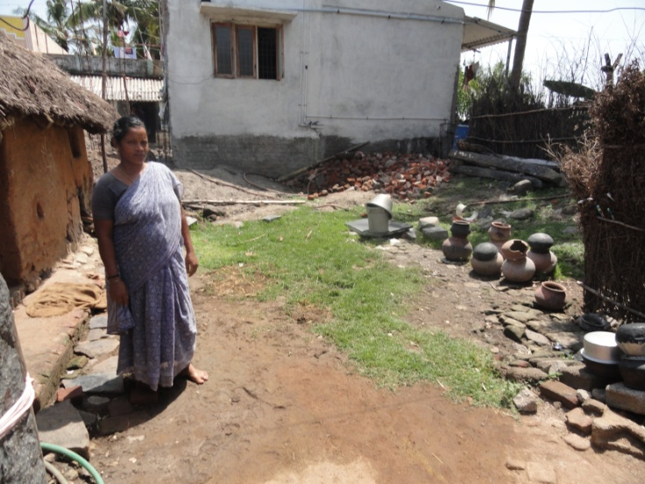

Beneficiary: Mrs.Sivagami- House Type: thatched roof

Beneficiary: Mrs. Poorani - House type: Govt. quarters